1. Project name: Increasing the availability of medical care for certain categories of citizens
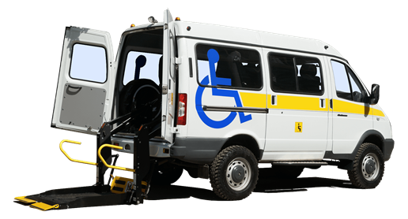
2. Duration of the project: 2022-2023 years
3. Applicant organization proposing the project: Healthcare institution «Orsha Central Polyclinic»
- 4. Project objectives:
- to expand opportunities for diagnostic and therapeutic measures for persons with disabilities (disabled people, elderly citizens with limited mobility, residents of rural areas)
5. Tasks planned for implementation within the framework of the project:
ensuring the availability of medical care, creating a barrier-free environment, free access to medical care for persons with disabilities
6. Target group: the project is designed for patients with disabilities, rural population of Orsha district
7. Brief description of the project activity:
purchase of 1 car for 8 seats for the organization of transportation of persons with disabilities, rural residents to health care institutions for the purpose of conducting a survey, which can only be carried out in the conditions of a health care organization
8. Total amount of financing (in US dollars): 70 000
Source of financing | Amount of funding  (in US dollars):
Donor funds | 70 000
Co-financing | –
9. Project location (region/district, city):
Vitebsk region, Orsha district, Orsha city, Muzeyny lane, house 1
10. Contacts: Karaka Sergey Anatol'yevich, hospital chief executive of the Healthcare Institution «Orsha Сentral Рolyclinic».
tel.: 8(0216) 51 88 21,
info@orshamed.by

