1. Project name: Improving the quality of laboratory diagnostics

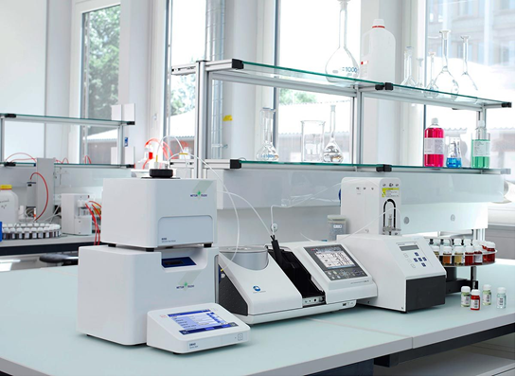
2. Duration of the project: 2022-2023 years
3. Applicant organization proposing the project: Healthcare institution «Orsha Central Polyclinic»
4. Project objectives:
1. Improving the quality of laboratory diagnostics for the population of the city of Orsha and Orsha, Dubrovensky, Tolochinsky districts.
2. High-quality performance of the preanalytical stage of preparation of biological samples for laboratory testing.
5. Tasks planned to be performed within the framework of the project:
organization of diagnostic work at a higher level using the capabilities of modern equipment
6. Target group: the project is designed for citizens of the city of Orsha and Orsha, Dubrovensky, Tolochinsky districts
7. Brief description of the project activity:
purchase of laboratory equipment:
laboratory binocular microscope – 6 pcs.;
enzyme immunoassay (semi–automatic) – 3 pcs.;
laboratory centrifuge – 3 pcs.;
automatic hemocoagulometer – 1 pc.;
laboratory counter – 4 pcs.;
thermoshaker – 1 pc.;
microplate washer – 1 pc.
8. Total amount of financing (in US dollars): 135 000
Source of financing | Amount of funding  (in US dollars):
Donor funds | 135 000
Co-financing | –
9. Project location (region/district, city):
Vitebsk region, Orsha district, Orsha city, 78 Mira Street (polyclinic No. 3)
10. Contacts: Karaka Sergey Anatol'yevich, hospital chief executive of the Healthcare Institution «Orsha Сentral Рolyclinic».
tel.: 8(0216) 51 88 21,
info@orshamed.by

