1. Project name: Improving the quality of perinatal medical care

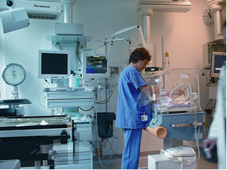
2. Duration of the project: 2022-2023 years
3. pplicant organization proposing the project: Healthcare institution «Orsha Central Polyclinic»
4. Project objectives:
improving the quality of perinatal medical care, reducing perinatal losses
5. Tasks planned for implementation within the framework of the project:
organization of specialized obstetric and gynecological care for the female population and newborns
6. Target group: the project is designed for citizens of Orsha and Orsha district, foreign citizens
7. Brief description of the project activity:
purchase of equipment for the city maternity hospital:
neonatal incubator – 2 pcs.;
neonatal laryngoscope with a set of blades – 3 pcs.;
portable ultrasound device (for newborns) – 1 pc.;
phototherapy device (for newborns) – 2 pcs.;
anesthesia breathing apparatus for adults – 2 pcs.;
artificial lung ventilation device (for adults) – 2 pcs.;
dry–burning cabinet for 250 liters – 1 pc.;
high–end ultrasound machine – 1 pc.;
mobile digital X-ray machine – 1 pc.
8. Total amount of financing (in US dollars): 317 000
Source of financing | Amount of funding  (in US dollars):
Donor funds | 317 000
Co-financing | –
9. Project location (region/district, city):
Vitebsk region, Orsha district, Orsha city, Vladimir Korotkevich Street, house 11 (city maternity hospital)
10. Contacts: Karaka Sergey Anatol'yevich, hospital chief executive of the Healthcare Institution «Orsha Сentral Рolyclinic».
tel.: 8(0216) 51 88 21,
info@orshamed.by

